



**Students number:**

Grigor Danut x16114515

Antonio Penna x01417383

Ruben Campean x16120043

Umar Rafique x18142061

**Team Project**:

**Date:** Friday 14 of December

**Submitted to**: Manuel Tova-Izquierdo

Table of Contents

Product Overview 3

Requirements Specification Migration 3

Self reflective analysis of the initial Gantt chart submitted 3

Discussion on the benefits of using SCRUM 5

Challenges Encountered 6

Conclusion and Future Work 6

# Product Overview

Released on Android Play Store, Smart Doctor is an application that allows medical staff to record, update, store, maintain, change and delete vital patient medical history and records that are stored in a database that is linked to the application. Through the use of NFC on their mobile devices such as tablets and mobile phones with the application installed on it, patient records and medical histories essentially becomes mobile and accessible in dire situations. Proving especially useful in cases of emergencies, paramedics are now able to access the information they need in emergency call outs in a manner that reduces the time spent on such a call out. By implication using the application also potentially increases the life chances of the patient in question, because Smart Doctor reduces time between arrival at the emergency scene to when the patient receives medical treatment.

# Requirements Specification Migration

Upon the completion of an initial business analysis, it was elicited that the stakeholders consist of multiple clients, consisting of Doctors, Hospitals and Health Service Executives. The first elicitation technique for gathering information pertaining to the functional requirements of these stakeholders issued as series of telephone conversations. During these, it became apparent that the most important feature of the application for all stakeholders involved was user security, -accessibility and -scalability. In the case of Smart Doctor, no migration of existing functions is required, as the application is a solution that is built from the ground up. However, the initial stakeholder requirement for a fingerprint reader solution could not be met, due to the fingerprint reader being an unsupported technology. For security reasons, in compliance with new Data Protection Laws that took effect in March 2018, third parties cannot access fingerprint reader information. Decidedly, NFC card reader replaced the fingerprint reader functionality in the original stakeholder requirements specification.

In a further series of interviews with stakeholders, it was established that once the application is downloaded by the user, who is required to register for the service with a valid e-mail address, a verification e-mail follows to ensure user security. User data will be password protected, as another layer of security.

# Self-reflective analysis of the initial Gantt chart submitted

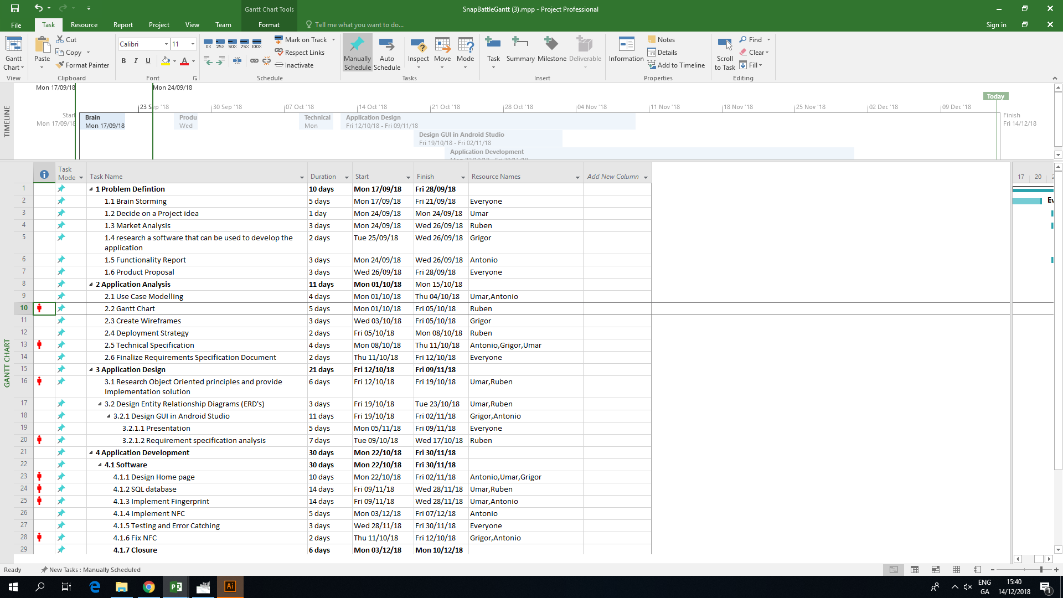

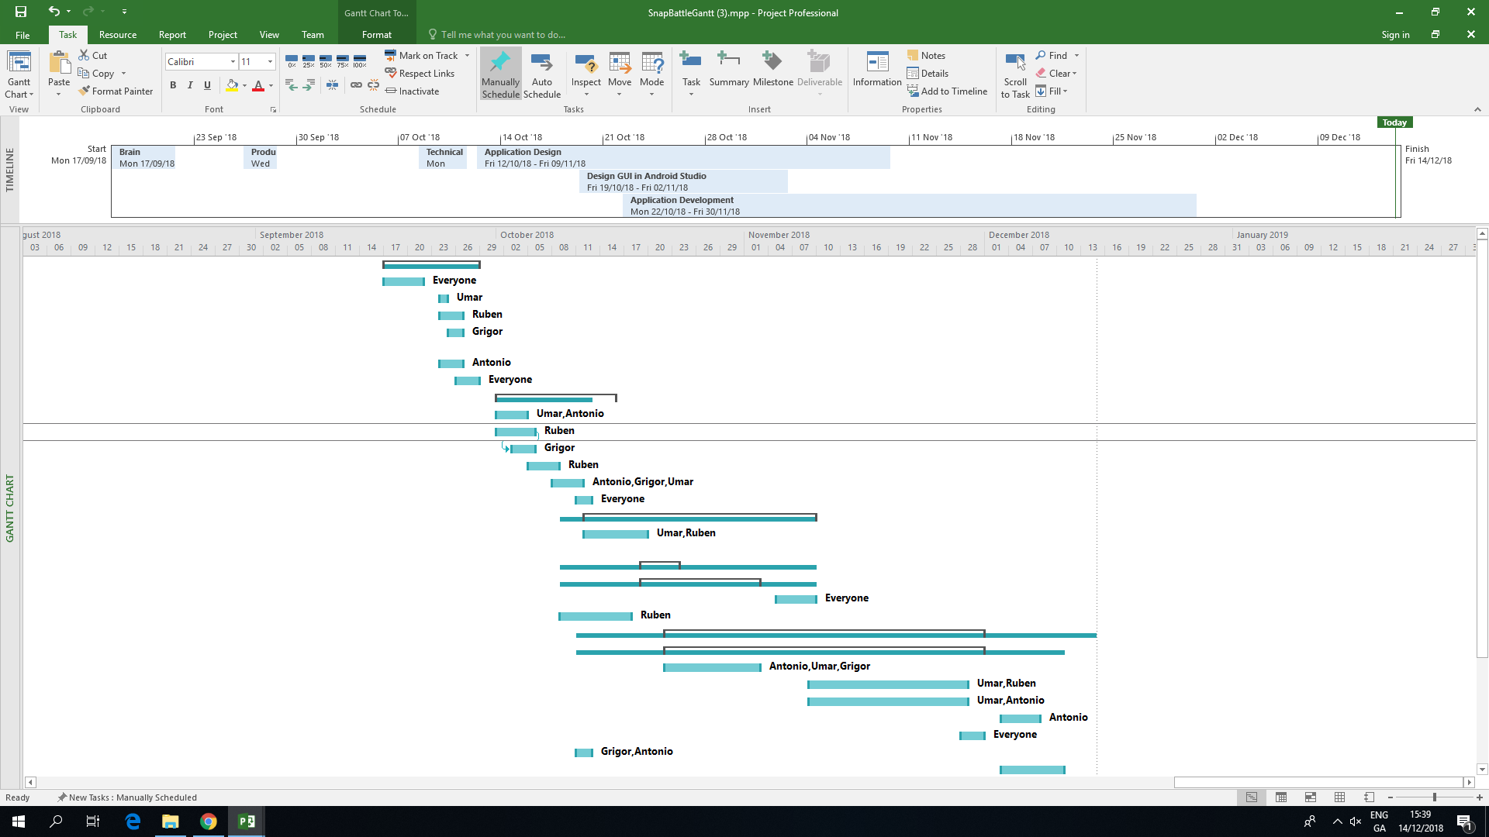

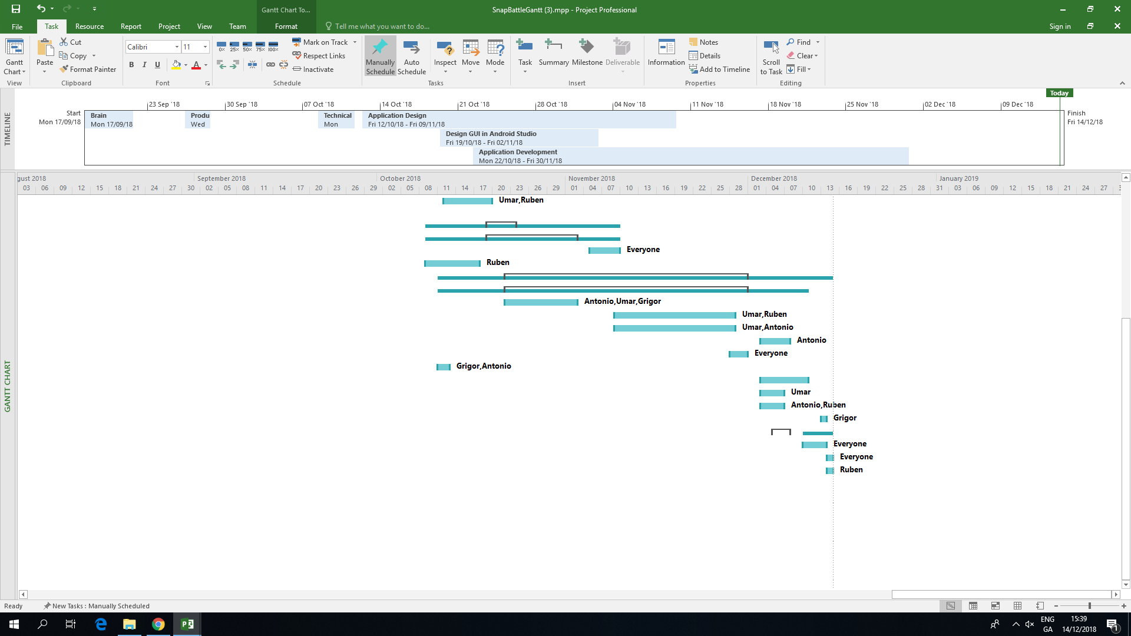

Each group was required to de-couple their project into manageable chunks and create a suitable Gantt Chart to illustrate the timeline for their project. Groups should now evaluate their initial expectations and provide a new updated Gantt chart with the actual build times completed. A discussion should also be included to give insight into the differences between both graphs submitted.

# Discussion on the benefits of using SCRUM

The group consensus is that by using scrum tactics, meeting the completion of the project was aided. By using scrum meetings the group was able to discuss challenges encountered throughout the weeks and each member was given time to come up with advance a solution to the issues encountered. The idea of having different project managers every each week allowed each member to step out of their comfort zone and take leadership of the project and allow them to lean hone important leadership skills that will prove valuable in future workplace endeavours as well as Teamwork skills were also improved and it was once again reiterated that leading isn’t just giving orders and delegating tasks but more so understanding the needs of the team and spending time resolving issues either with the project or with the team itself. Every member in the group agrees that the completion of the project was made easier using the SCRUM model.

# Challenges Encountered

The first difficulty was how the original idea of a fingerprint reader was stifled as this facility was phased out and discarded by manufacturers in compliance with new privacy laws that took effect in 2018. This feature is now being kept on for authentication purposes only. Android restricted fingerprint reader access on devices for multiple users and this posed an obstacle to the aims of our project.

NFC, after much deliberation and research, replaced the fingerprint reader function, which brought about new challenges, with its implementation. Firebase data retrieval with NFC was a challenge also, because Firebase only allows for the retrieval of primary keys, which in our case is an e-mail address. This made the application crash and a walk around this was necessary in the form of creating a new Activity and retrieve data from it.

(NFC Tutorials, 2015)

Kotlin language, being a new language brought its own set of challenges. For one, its newness demanded research and tutorials. (Apps In The Sky, 2018)

# Conclusion and Future Work

The group worked well together because it was established since the first meeting that everyone worked towards the same goal. This in itself lead to our first important analysis as concerning team work, ie substantively determining each team member’s weakness and strength from the onset. In this way, we could focus on the groups weaknesses that was turned into strengths as each member could exchange with another a weakness for a strength when tasks were chosen and allocated.

Whenever a disagreement arose it was dealt with in an efficient manner. Everyone felt included in the project and each member of the group feel like they’ve learned something new about teamwork as well as developing applications using Android Studio. The experience each member had as part of this group was a positive one.

Each member of the group feel like they’ve learned something new about teamwork It happened on many occasions that a member needed support with something that needed to be done for the project and it was very comforting knowing that asking other group members who might understand the problem how to figure it out. As well as learning how to use something new which you’ve never used before and meeting new people. The group worked well together, whenever a disagreement arose it was dealt with swiftly and nobody felt offended.

Going forward the group look to continue working together on this product improving on it and the main goal the group has for this product is to bring it to market by releasing the application on the Android Play Store.

This section should conclude with a discussion centered around the groups experience with working in a team and the future expectations that the group have for their product.

# Bibliography

Apps In The Sky. (2018). *Kotlin 101: How To Read Data From Firebase Part 1*. [online] Available at: https://www.youtube.com/watch?v=NCU1RE93wy4 [Accessed 8 Nov. 2018].

NFC Tutorials. (2015). *Android NFC Tutorial [04] - How to read text from a NFC tag*. [online] Available at: https://www.youtube.com/watch?v=bbeS7FPjRNk [Accessed 4 Dec. 2018].

Karthik M. (2016). *How to create Android Contact Form - AndroidMkab.com*. [online] Available at: https://www.youtube.com/watch?v=AV13zohVHBg [Accessed 25 Oct. 2018].

YouTube. (2018). *Using Recyclerview to show data from Firebase Database*. [online] Available at: https://www.youtube.com/watch?v=vpObpZ5MYSE [Accessed 14 Oct. 2018].

YouTube. (2018). *Retrieve data on ListView from Firebase Realtime Database Part 4*. [online] Available at: https://www.youtube.com/watch?v=MP3tialkL2Y [Accessed 22 Oct. 2018].

YouTube. (2018). *Login and Register | Sqlite Database | Android Studio | Part 1*. [online] Available at: https://www.youtube.com/watch?v=1WPAXHhG6u0 [Accessed 17 Nov. 2018].

YouTube. (2018). *firebase realtime database android - Saving Data part-1*. [online] Available at: https://www.youtube.com/watch?v=aCDgP2By1J0 [Accessed 14 Dec. 2018].

YouTube. (2018). *How to Insert multi data from Android app into Firebase - part 4*. [online] Available at: https://www.youtube.com/watch?v=iLpAPvwHrpk [Accessed 19 Oct. 2018].

YouTube. (2018). *Simple Login App using Database (PART 9) - Updating User Info! (Android Studio 3.0.1)*. [online] Available at: https://www.youtube.com/watch?v=gtRQxYKLARg [Accessed 28 Oct. 2018].